[Enter Post Title Here]

1. Wap to insert an elen=ment into an array:

import java.util.Arrays;

public class Exercise9 {

public static void main(String[] args) {

int[] my_array = {25, 14, 56, 15, 36, 56, 77, 18, 29, 49};

int Index_position = 2;

int newValue = 5;

System.out.println("Original Array : "+Arrays.toString(my_array));

for(int i=my_array.length-1; i > Index_position; i--){

my_array[i] = my_array[i-1];

}

my_array[Index_position] = newValue;

System.out.println("New Array: "+Arrays.toString(my_array));

}

}

Output :

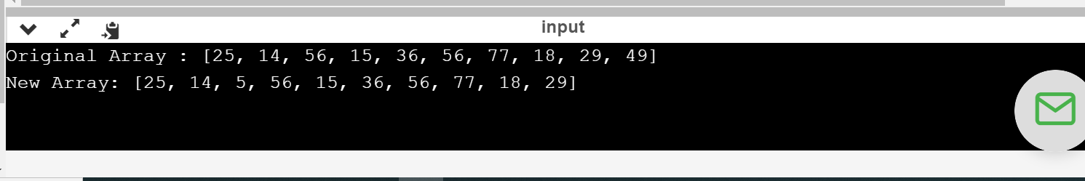

2.wap to sort a numeric array and a string array:

import java.util.Arrays;

public class Main {

public static void main(String[] args){

int[] my_array1 = {

67,56,45,67};

String[] my_array2 = {

"Java",

"Python",

"PHP",

"C#",

"C Programming",

"C++"

};

System.out.println("Original numeric array : "+Arrays.toString(my_array1));

Arrays.sort(my_array1);

System.out.println("Sorted numeric array : "+Arrays.toString(my_array1));

System.out.println("Original string array : "+Arrays.toString(my_array2));

Arrays.sort(my_array2);

System.out.println("Sorted string array : "+Arrays.toString(my_array2));

}

}

Output:

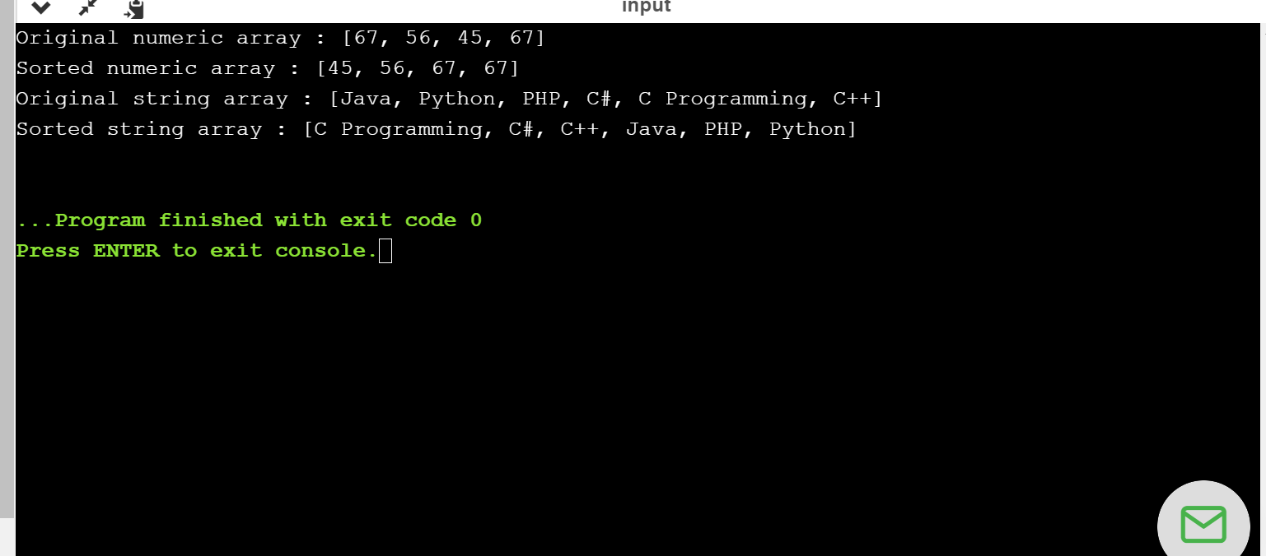

3.wap to reverse an array of integer value:

import java.util.Arrays;

public class Main {

public static void main(String[] args){

int[] my_array1 = {

9,8,7,6,5,4,3,2};

System.out.println("Original array : "+Arrays.toString(my_array1));

for(int i = 0; i < my_array1.length / 2; i++)

{

int temp = my_array1[i];

my_array1[i] = my_array1[my_array1.length - i - 1];

my_array1[my_array1.length - i - 1] = temp;

}

System.out.println("Reverse array : "+Arrays.toString(my_array1));

}

}

Output:

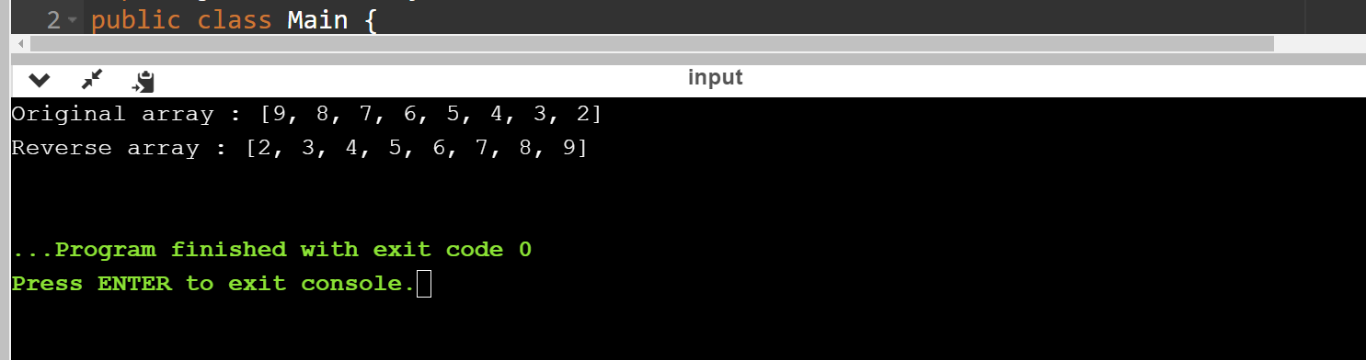

Wap to find the common element between two array of integer:

import java.util.Arrays;

public class Main {

public static void main(String[] args)

{

int[] array1 = {45,56,34,6};

int[] array2 = {1, 0, 6, 15, 6, 4, 7, 0};

System.out.println("Array1 : "+Arrays.toString(array1));

System.out.println("Array2 : "+Arrays.toString(array2));

for (int i = 0; i < array1.length; i++)

{

for (int j = 0; j < array2.length; j++)

{

if(array1[i] == (array2[j]))

{

System.out.println("Common element is : "+(array1[i]));

}

}

}

}

}

Output:

